4G video and audio law enforcement recorder
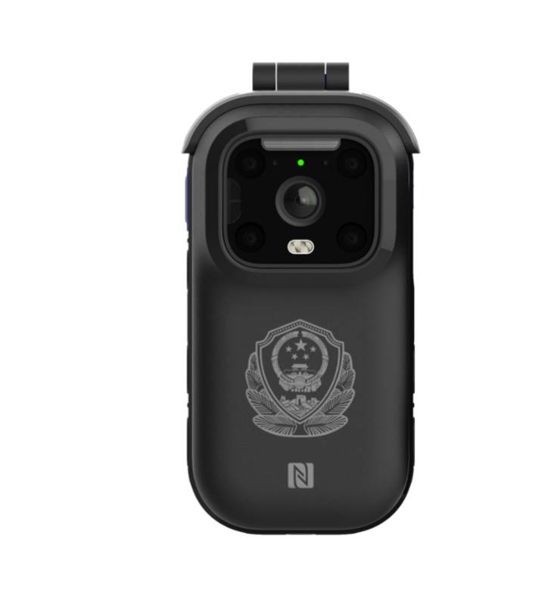
- Product Overview
The DSJ-IQCY2 series 4G video and audio law enforcement recorders have been fully upgraded in terms of appearance, performance, functionality, and experience. They adopt a more ergonomic circular arc design, introduce ultra-low power domestic chips, enable fingerprint recognition unlocking, and are compact and lightweight. They can achieve functions such as data uploading, law enforcement evidence collection, intelligent recognition, video conferencing, etc. They can be widely used in industries such as public security, urban management, power, railway, and water conservancy.
- Features
Android 10.0 Humanized Operation
Starlight night vision and clear night shots
Four core+2.0GHz ultra-high CPU performance
3200mAH detachable lithium battery
5V/2A fast charging
Fingerprint recognition security unlock
IP68 protection level
Free switching between front and rear dual cameras
1080P dual stream transmission
Beidou/GPS dual-mode positioning
- Product Parameters
project | technical parameter
system | Android 10
CPU | 4-core, up to 2.0GHz
Memory | RAM≥2GB，ROM≥16GB
screen | 3.1-inch IPS HD touch display with 480*800 resolution and 5-point touch support
key | Power button, video button, photo button, audio button, emergency alarm button, intercom button, key marker button
data interface | Micro USB, supports charging and data transfer
fingerprint identification | support
NFC/OTG | Support
camera | 500W wide-angle main camera + 200W conference camera
video coding | H.264
Video resolution | 1080P/720P
audio frequency | Built-in noise-canceling microphone and 1.5W speaker
mobile network | Supports 4G networks of China Mobile, China Unicom, and China Telecom
Wi-Fi | support
PDA | support
memory | Expand your TF card storage up to 256GB
fixed position | Supports BeiDou/GPS
the light of a lamp | Infrared light, red and blue warning lights, flashing lights, status indicator lights
Night vision | 3m to see faces, 5m to see body outlines
charge | Standard 5V/2A, optional seat charging
power supply mode | 3200mAh replaceable lithium battery, supports battery replacement without shutting down
Protection Level | IP68
work environment | Working temperature: -30℃~+55℃; Storage temperature: -40℃~+60℃
Weight dimensions | 185g (including battery); size: 108*56*24 (mm)

